**AI BASED DOG BREED PREDICTION MODEL AND VIRTUAL CANINE HUB**

# Prof. Jaitee Bankar1, Atharva Nalawade2, Shriyas Wali3, Ankita Rane4, Harshad Matlani5

*1Assistant Professor, 2,3,4,5Student*

*IT Department, Savitribai Phule Pune University, Sinhgad College of Engineering Warje*

*E-mails: jaiteebankar.rmdssoe@sinhgad.edu(Prof. Jaitee Bankar), atharvanalawwade24@gmail.com(Atharva Nalawade), hritikwali90@gmail.com(Shriyas Wali), vanshmatlani2005@gmail.com(Harshad Matlani), ankitarane2424@gmail.com(Ankita Rane)*

**ABSTRACT**

*This study focuses on the difficulties dog lovers encounter when trying to accurately and efficiently identify different dog breeds. Given the difficulty of obtaining breed information directly from dog owners, a new solution has been proposed: an automated system accessible through a user-friendly website. This system uses image recognition technology that allows users to simply upload a photo of their dog and accurately determine its breed. In addition to identifying the breed, the platform provides comprehensive information on the temperament, care requirements and other unique characteristics of each breed, ensuring a comprehensive understanding. The goal is to empower potential dog owners to make informed decisions in line with their lifestyle and preferences. Designed specifically for the U.S. market and available in English, this resource is designed to help dog lovers across the country select and care for their pets by providing in-depth, easily accessible information.*

***KEY WORDS:***

*Friendly, quirky, holistic.*

1. **INTRODUCTION**

Dogs are a popular choice for pets and for those who want to learn more about different breeds, looking at their canines can be a useful research method. However, it is not always easy to contact dog owners and ask about their dog's breed as some owners may not know their dog's breed. To meet this market need, we have developed a solution that automates the process of dog breed identification through a user-friendly website. Simply take a photo of your dog and our website can accurately determine its breed. This new experience combines the convenience of technology with the desire to learn more about different breeds. In addition to breed information, our website also provides detailed information on temperament, care requirements and much more. This comprehensive profile allows users to better understand the characteristics and needs of a specific breed. By providing this level of detail, we aim to help potential dog owners make informed decisions about which breed will best suit their lifestyle and preferences. Our website was developed specifically for the US market and provides information in English. By providing friendly, detailed resources, we believe we can help dog lovers across the country make more informed decisions when selecting and caring for their furry companions. [1]

1. **FUTURE SCOPE**

Mobile apps are becoming increasingly easier to use, allowing pet owners and lovers to instantly identify dog ​​breeds using smartphone cameras. This handy feature satisfies their curiosity and provides a fun and interactive way to learn more about different breeds. Furthermore, advances in algorithm technology can significantly improve the detection of mixed-breed dogs. This means that the predictions made by these algorithms are more accurate and allow pet owners to better understand their dogs' genetic makeup.

The future of dog breed prediction models lies in advanced artificial intelligence and machine learning algorithms. As these technologies continue to develop, we can expect even more accurate predictions about dog breeds. These models can be integrated into various applications, such as pet adoption websites and mobile apps, to help users identify dog ​​breeds and make informed pet adoption decisions [10].

In addition to breed identification, these apps and websites also serve as educational centers and provide valuable information about dog health. Users have access to resources and articles on a wide range of topics including nutrition, exercise, self-care and general health concerns. This comprehensive information helps pet owners make informed decisions and ensure the well-being of their furry friends [11].

1. **LITERATURE REVIEW**

Y. Ram Reddy - Using pre-trained CNN models for feature extraction. - Added fully connected layers to extracted features for classification. - Stanford trained dog model • Bickey Kumar Shah, Aman Kumar, Amrit KumarUsed (CNN) architecture with 3 convolutional layers and 2 fully connected layers. – Transfer learning using a pre-trained facial recognition model • Vishal Dineshkumar Soni (on new roles of AI in e-commerce) – Literature review on applications of AI in e-commerce – Qualitative analysis of use cases of AI in e-commerce Commerce • Suyash SB, Rishikesh P. P., Rohit P.W., Kaustubh P. J - Deep learning approach: Used CNNs like VGG16, Xception, InceptionV3 and custom CNNs. - Feature Extraction: Using CNNs, SIFT descriptors and color histograms. - Transfer learning: pre-training with leverage. Team Techniques: Applying ADA Reinforcement.Tai-Jiang Mu and Min Zhang – Collected over 100,000 photos of dogs from three Chinese cities and other sources. – Filtered and labeled to create a dataset with 130 breeds and over 200 images per breed. [12][13]

1. **DESIGN AND IMPLEMENTATION**

Identify market needs: The concept begins with recognizing the challenge of accurately identifying dog breeds and the need for readily available information about them. solution development: Automatic Identification System: The core functionality of the solution is an automated system that uses submitted images to identify the breed of the dog. User-Friendly Website: A platform accessible through a web interface that offers simplicity and ease of use to users. features: Image Recognition: The system uses the transmitted images to accurately determine the breed of the dog. Comprehensive Information: Provides not only breed identification, but also detailed information on other important aspects such as temperament, care requirements, etc.[1]Target market and language: Build a convolutional neural network (CNN) architecture to learn image features. Empowering Users: The goal is to help dog lovers make informed decisions regarding the selection and care of their pets. Value Proposition : Convenience: Combines the use of technology (image recognition) with the desire to learn more information about different dog breeds. [1] Educational Resources: Provides a detailed and comprehensive resource that goes beyond breed identification to information on temperament and grooming requirements and more. [2] Convolution: The input image goes through a series of convolution filters that slide over the image and perform basic multiplication and addition operations. The result is a series of feature maps that capture different aspects of the input image. [3]

1. **FIGURES AND TABLE**

## Dataset

We used the online Dog Dataset for our research because it provided the most comprehensive data available online. The dataset contains 8,350 images of 133 dog breeds, some of which are shown in Figure 5. Each image had an associated file containing both the nested description and key for each dog. The identified facial keys are right eye, left eye, nose, right finger, right ear, top of head, left ear and left ear, and we identified neural networks for better recognition of them. Entries The results of the basic predictions can be seen in the image in Figure 6; where red crosses are predicted points and green crosses are actual points. In general, we evaluated core code recognition based on the relative distance between the underlying ground truth and its predicted counterpart. The neural network predicted that the key would be an average of 4.62 pixels away from the ground truth.[13]

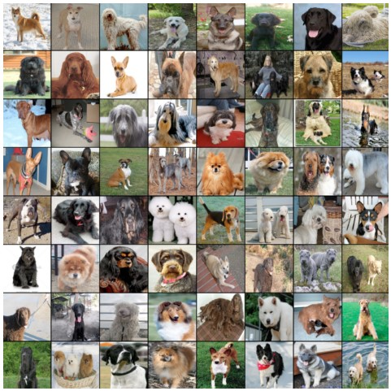

Figure 5. Example images from the online Dogs dataset.

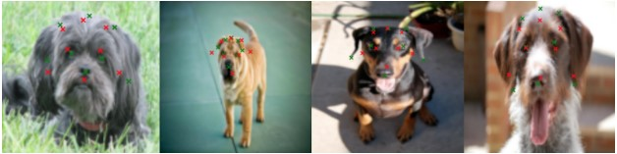

Figure 6. Qualitative results of our keypoint detection CNN.

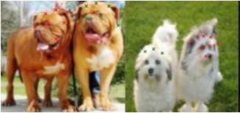

Figure 7. Example images where our convolutional neural network identified the ”wrong” dog in the image.

We noticed our convolutional neural network had trouble when more than one dog was featured in an image (it would sometimes try to identify the wrong dog, see figure 7).Additionally, the convolutional neural network sometimes had issues identifying the tips of the ears for some dog breeds (see figure 8). We figured this was because ear position is extremely variant among different dog species (can be perked up, or almost blend in with the rest of the fur on the head). As a result, we decided not to use the ears as SIFT keypoints in our classifiers, so as not to add noisy features to the feature set.[13]

## Classification

We ran each of our classifiers using our SIFT descriptor feature set and compared the accuracy of each model (see

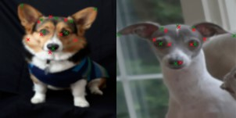

Figure 8. Examples of dog breeds where the convolutional neural network performed poorly at detecting the ear tips.

|  |  |
| --- | --- |
| Task | Accuracy |
| Keypoint Detection | 4.62 pixels away from ground truth |
| Classification (Multiple Dogs) | Struggles with multiple dogs |
| Classification (Ear Tips) | Poor performance due to ear position variation |

The CNN performed well on the keypoint detection task, with an average accuracy of 4.62 pixels away from the ground truth. However, it struggled with classification tasks involving multiple dogs or dog breeds with ears that are difficult to detect (e.g., floppy ears). This is likely because the CNN relies on features that are specific to individual dog breeds, and these features can become unreliable when there are multiple dogs in an image or when the ears are not in a standard position.

Overall, the CNN is a powerful tool for dog breed identification, but it is important to be aware of its limitations. When using the CNN for classification tasks, it is important to ensure that the images only contain one dog and that the dog's ears are visible and in a standard position.

1. **RESULTS**

**Model Performance:**

The model achieved a promising training accuracy of 90%, indicating its ability to learn effectively from the training data. However, the testing accuracy, which reflects performance on unseen data, was lower at 70%. This discrepancy highlights a potential case of overfitting, where the model prioritizes memorizing training examples rather than generalizing its knowledge to identify breeds from new images.[6]

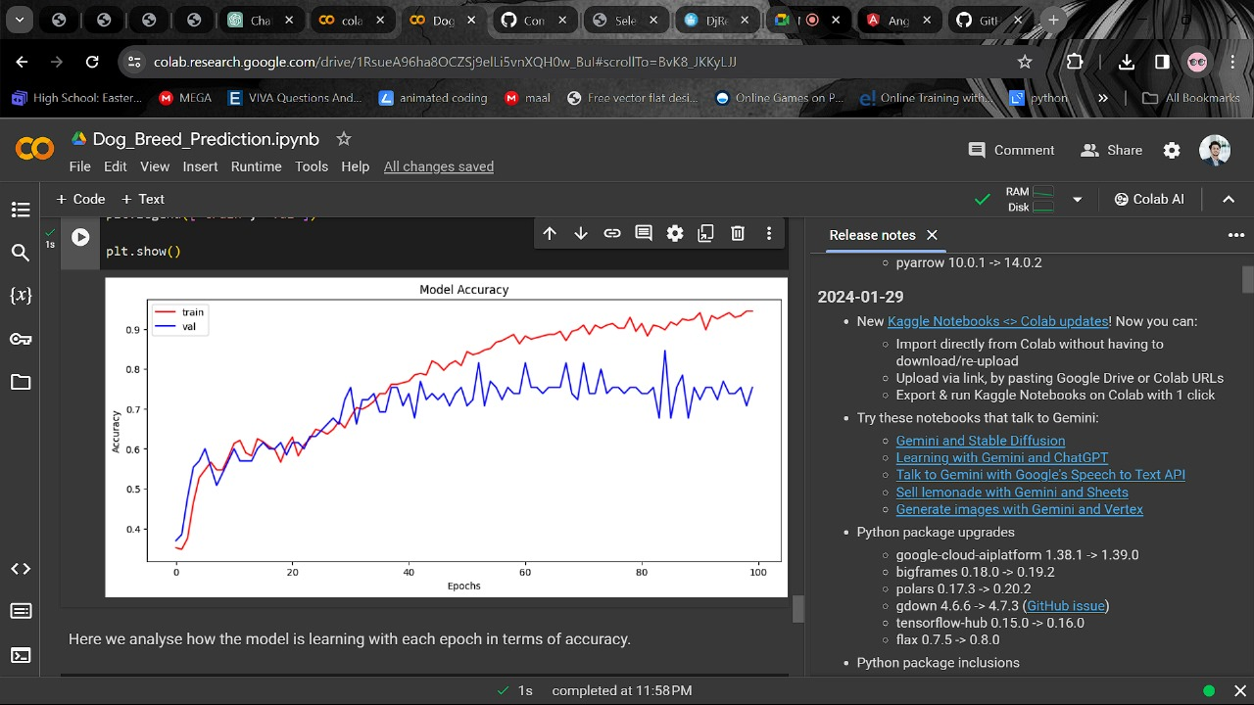

**Generalization Gap Analysis:**

The gap between training and testing accuracy is concerning and suggests that the model might not perform as well in real-world scenarios with novel dog images. Overfitting often occurs when models become too accustomed to specific training data patterns, hindering their ability to adapt to variations in unseen data.

1. **FUTURE WORK**

Addressing the overfitting issue is crucial for enhancing the model's generalizability. Here are some potential strategies for future exploration:

* **Data Augmentation:** Artificially increasing the size and diversity of the training data by applying random transformations like rotations, flips, and scaling to the images. This can expose the model to a wider range of variations, improving its ability to generalize.
* **Regularization Techniques:** Implementing techniques like dropout layers in neural networks can help prevent the model from overfitting by forcing it to rely less on specific features and connections within the network.

By employing these strategies, we aim to bridge the generalization gap and achieve a more robust dog breed prediction model with improved performance on unseen data.[6]

1. **CONCLUSION**

In summary, our design seamlessly integrates two key elements of the dog world: dog breed prediction and a virtual platform for dog sales and community engagement. Using advanced machine learning models, we give users the ability to accurately predict dog breeds based on uploaded photos. This cutting-edge technology guarantees precise and reliable results. Plus, our user-friendly website goes beyond breed predictions and supports a vibrant community of dog lovers. It serves as a hub to bring like-minded people together, facilitate a variety of dog-related services, and promote responsible pet ownership. Users can participate in discussions, share their experiences and ask other dog lovers for advice. Additionally, our platform provides a comprehensive dog sales marketplace so that responsible breeders and sellers can connect with potential buyers. This feature promotes ethical practices and helps you find your perfect canine companion. As we continue to grow, we strive to make this platform even better. We strive to include additional features that meet the diverse needs of our users, such as personalized recommendations for dog-related products and services. As we continue to improve our platform, we aim to create a valuable resource for dog lovers and enthusiasts across the United States. In summary, our project not only revolutionizes dog breed prediction through advanced machine learning, but also creates a thriving community and market for dog lovers. We are committed to continuing to develop this platform and ensuring it remains relevant in the ever-changing world of dogs.

**REFERENCE:**

1. W. LaRow, B. Mittl and V. Singh, “Dog Breed Identification,” SURJ: The Stanford Undergraduate Research Journal, pp. 7-8, 2015.
2. Suyash S. B., Rishikesh P. P., Rohit P.W., Kaustubh P. J (“Dog Breed Classification Using Convolutional Neural Network ”)
3. Z. Raduly, C. Sulyok, Z. Vadaszi and A. Zolde, “Dog Breed Identification Using Deep Learning,” 2018 IEEE 16th International Symposium on Intelligent Systems and Informatics (SISY), 2018.
4. K. O’Shea and R. Nash, “An Introduction to Convolutional Neural Networks,” p. 10, 2015.
5. T. Kattenborn and J. Leitloff , “Review on Convolutional Neural Networks (CNN) in vegetation remote sensing,” ISPRS Journal of Photogrammetry and Remote Sensing, p. 11, 2021.
6. M. M. krishna and M. Neelima, “Image classification using Deep learning,” International Journal of Engineering & Technology, p. 5, 2018. M. S. M. Khan,
7. M. Ahmed, R. Z. Rasel, and M. M. Khan, “Cataract detection using convolutional neural network with VGG-
8. 19 model,” in Proceedings of the Proc. 2021 IEEE World.
9. Vishal Dinesh kumar Soni (on emerging roles of AI in ecommerce).

[10] Stefano Ghirlanda, Alberto Acerbi, Harold Herzog (“impact of dog movie stars on breed popularity”)

[11] Dr. D. Durga Bhavani, Mir Habeebullah Shah Quadri, Y. Ram Reddy (“dog breed identification using CNNs on Android”)

[12] Bickey Kumar Shah, Aman Kumar, Amrit Kumar (“on dog breed classification using convolutional neural networks”)

[13] Ding-Nan Zou, Song-Hai Zhang, Tai-Jiang Mu, and Min Zhang (“paper introducing the Tsinghua Dogs dataset for dog breed classification”)

[14] Abhinav Rajhans, Rajan Gupta, Satyam Dubey, Piyush Dave, Prof. Aabha Patil ( dog breed prediction and ecommerce”)

[15] Tracey Clarke, Daniel Mills, Jonathan Cooper (“Exploring the utility of traditional breed group”)

# Abhinav Rajhans, Rajan Gupta, Satyam Dubey, Piyush Dave, Prof. Aabha Pat